**Machine Learning**

Machine learning is a method of teaching prediction based on some data. it is a branch of artificial intelligence, Which numerically improves on data. Over as more data as add in algorithm the performance of the system is improved.

These are the three types of machine learning:

**Supervised learning** its supervised learning we have several data points or samples described using predictive variables or features and the target variable our data represented in table structure. Game supervised learning is build a model its able to predict the target variable.

**Unsupervised learning** is a machine learning task the uncovering hidden patterns from unlabeled data.

**Reinforcement learning** (RL) in which machine or software agents interact with an environment reinforcement learning agents are able to automatically figure out how to optimize their behavior given a system of reward and punishments reinforcement learning draws inspiration from behavioral psychology..

**Computer Vision**

It is a field that includes processing analyzing and understanding image in general high dimensional data from the real world in order to produce numerical and symbolic information or it is a technology of science and machine that see it obtain information from images.

**Deep Learning**

Deep learning is a powerful set of techniques for learning using neural network. Neural network are beautiful biologically inspired programing paradigm which enables a computer to learn from data. These are learning algorithms

**Open CV**

OpenCV (Open Source Computer Vision Library) is a collection of algorithms for computer vision. it basics focus on real time image processing it is free for commercial and research use under a BSD license*.*.

**TensorFlow**

TensorFlow is a mathematical computation library for training and building your machine learning and deep learning model with a simple to use high level APIs.

**Keras**

Keras is a neural network API. It is library written specifically in python. Also, It works with other libraries and packages such as tensorflow which makes deep learning easier. Keras was developed to allow for quick experimentation and for fast prototyping.

**CNN**

Convolutional Neural Network are designed to process data through multiple layers of arrays. This type of neural networks is used in application like image recognition of face recognition. The primary difference between CNN and other ordinary neural network is that CNN takes input as a two dimensional array and operates directly on the images rather than focusing on feature extraction which other neural network focus on.

The dominant approach of CNN includes solutions for problems of recognition. Top companies like google and facebook have invested in research and developments towards recognition projects to get activites done with greater speed.

A convolutional neural network uses three basic ideas:

* Local respective fields.
* Convolution
* Pooling

**Artificial neural network**

I am using different architecture and models of ANN were used for face mask detection. ANN can be used in face mask detection because these models can simulate the way neurons work in human brain. I comparison between different neural network for face mask recognition system and lastly we use those model which have better accuracy.

**Retinal connected of neural network (RCNN)**

I am presented face mask detection system based on a RCNN that examine small windows of an image to check each window contain face with or without mask. First, a preprocessing step, adapted from, is applied to window of the image. Then window is passed through the neural network, which decides whether the window contain face with or without mask. They used the two training dataset of image. In first dataset with mask images collected by me consist of total 800 images. The second dataset without mask consist of 750 images, The recognition face with mask and without mask equal to 80% accuracy rate.

**Principal Component Analysis with ANN:**

I am using PCA with class specific linear projection to detect or recognized face with or without mask in a real time video stream. The system steps to search for face with or without mask in an image:

1. Select every 20x20 region of input image
2. Use intensity values of its pixel as 400 inputs to ANN
3. Feed values is forward through ANN and
4. If the value is above 0.5 the region represent a face
5. Repeat steps several times, each time on a resized version of the original input image to search for faces at different scales.

**Convolution Neural Network**:

In this planned method, the mask detection model is constructed victimization the successive API of the keras, library. this permits us to make the new layers for our model step by step. the assorted layers used for our CNN model is represented below.The 1st layer is that the Conv2D layer with one hundred filters and therefore the filter size or the kernel size of 3X3. During this first step, the activation operate used is the ‘ReLu’. This ReLu function stands for corrected linear measure which is able to output the input directly if is positive, otherwise, it'll output zero. The input size is also initialized as 150X150X3 for all the photographs to be trained and tested victimization this modelIn the second layer, the MaxPooling2D is employed with the pool size of 2X2The next layer is once more a Conv2D layer with another one hundred filters of constant filter size 3X3 and {also the} activation operate used is that the ‘ReLu’. This Conv2D layer is followed by a MaxPooling3=2D layer with pool size 2X2.

In consecutive step, we have a tendency to use the Flatten () layer to flatten all the layers into one 1D layer. After the Flatten layer, we use the Dropout (0.5) layer to forestall the model from overfitting. Finally, towards the end, we have a tendency to use the Dense layer with fifty units and therefore the activation operate as ‘ReLu’.

The last layer of our model are going to be another Dense Layer, with solely 2 units and the activation function used will be the ‘Softmax’ function. The softmax function outputs a vector which is able to represent the chance distributions of every of the input units. Here, two input units are used. The softmax function will output a vector with two probability distribution value.

**Fast Neural Networks (FNN)**

The proposed FNN for the face mask detection. A FNN approach to reduce the computational time for locating human faces with or without mask. Each image is divided into small sub images and then each one is tested separately using a fast ANN. The experimental result of comparison with conventional neural network showed that high speed achieved when applying FNN.

**Table 1: Comparison of neural network method**

|  |  |  |
| --- | --- | --- |
| **s.no** | **Methodlogy** | **Recognition rate (%)** |
| **1** | **RCNN** | **90.45** |
| **2** | **PCA with ANN** | **95.67** |
| **3** | **CNN** | **95.22** |
| **4** | **FNN** | **94** |

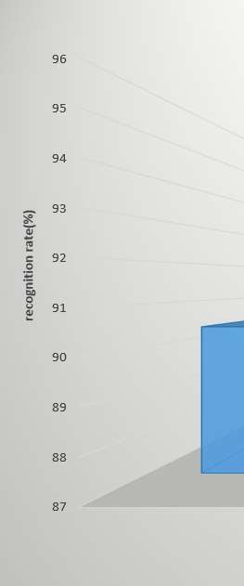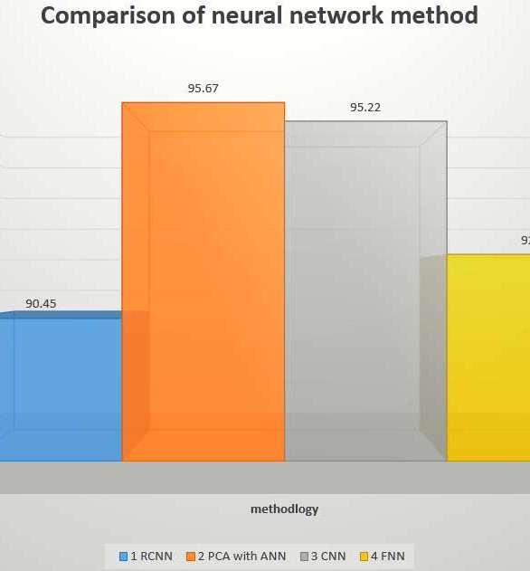

**Figure 1: visualization of neural network method comparison**

After the comparison the two best methodology is CNN and PCA with AAN both recognition rate approximately same then I am using for the CNN for the face mask detection mode.

9